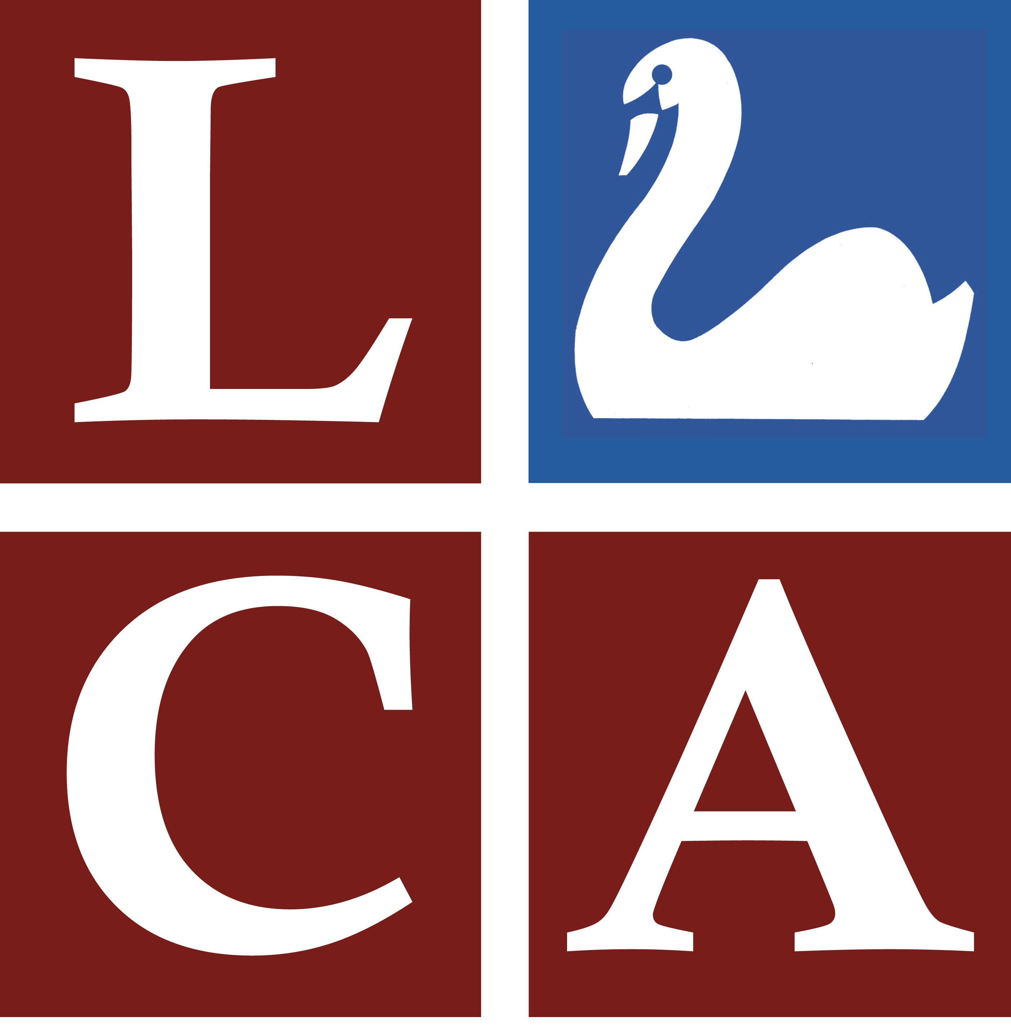
Leatherhead Institute Attendee.
Parking on levels 5 & 6 only.
Valid Swan Centre car parking tickets must be displayed alongside this permit and/or Ringo payment made.

Leatherhead Institute Attendee.
Parking on levels 5 & 6 only.
Valid Swan Centre car parking tickets must be displayed alongside this permit and/or Ringo payment made.

Leatherhead Institute Attendee.
Parking on levels 5 & 6 only.
Valid Swan Centre car parking tickets must be displayed alongside this permit and/or Ringo payment made.

Leatherhead Institute Attendee.
Parking on levels 5 & 6 only.
Valid Swan Centre car parking tickets must be displayed alongside this permit and/or Ringo payment made.

